1. **CSS的id与class的区别**

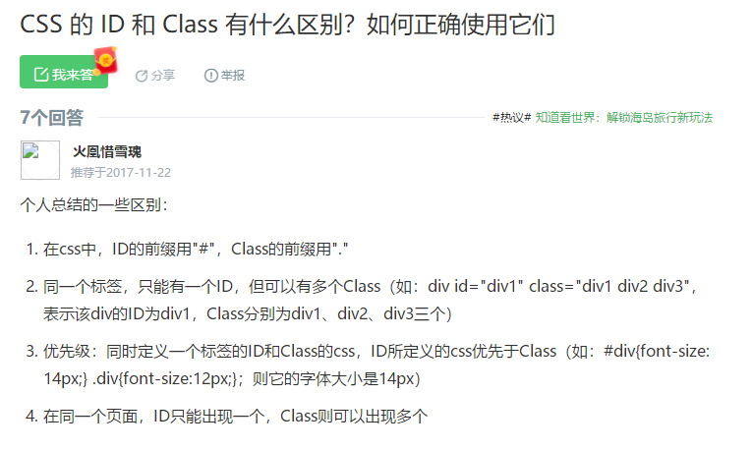

**2.margin、cellpadding、cellspacing与border**

**margin: auto；块元素居中**

**Text-align:: center 行元素居中**

**margin: A1px A2px A3px A4px**

**margin: (块元素外围的)上边界间隔A1 右边界间隔A2 下边界间隔A3 左边界间隔A4**

**cellpadding：table内部的元素与边框的间隔**

**cellspacing：table内部的所有内边框宽度**

**border：table边界的整体外边框宽度**

**3.table表格的合并方法**

**<ol>**

**<li>基本表格</li>**

**<table border="2" bordercolor="black" width="300" cellspacing="0" cellpadding="5">**

**<tr>**

**<td>1.1</td>**

**<td>1.2</td>**

**<td>1.3</td></tr>**

**<tr>**

**<td>2.1</td>**

**<td>2.2</td>**

**<td>2.3</td></tr>**

**<tr>**

**<td>3.1</td>**

**<td>3.2</td>**

**<td>3.3</td></tr>**

**</table>**

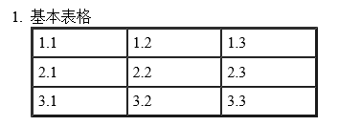

**<li>表格合并列</li>**

**<table border="2" bordercolor="black" width="300" cellspacing="0" cellpadding="5">**

**<tr>**

**<td colspan="3">1.1</td>**

**<!--<td>1.2</td>-->**

**<!--<td>1.3</td>--></tr>**

**<tr>**

**<td>2.1</td>**

**<td>2.2</td>**

**<td>2.3</td></tr>**

**<tr>**

**<td>3.1</td>**

**<td>3.2</td>**

**<td>3.3</td></tr>**

**</table>**

**<br/>**

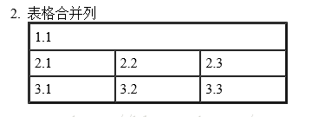

**<li>表格合并行</li>**

**<table border="2" bordercolor="black" width="300" cellspacing="0" cellpadding="5">**

**<tr>**

**<td rowspan="3">1.1</td>**

**<td>1.2</td>**

**<td>1.3</td></tr>**

**<tr>**

**<!--<td>2.1</td>-->**

**<td>2.2</td>**

**<td>2.3</td></tr>**

**<tr>**

**<!--<td>3.1</td>-->**

**<td>3.2</td>**

**<td>3.3</td></tr>**

**</table>**

**<br/>**

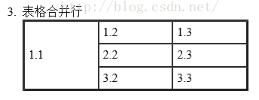

**<li>复杂表格</li>**

**<table border="2" bordercolor="black" width="300" cellspacing="0" cellpadding="5">**

**<tr>**

**<td>1.1</td>**

**<td colspan="2">1.2</td>**

**<!--<td>1.3</td>--></tr>**

**<tr>**

**<td>2.1</td>**

**<td rowspan="2">2.2**

**<br/>3.2</td>**

**<td>2.3</td></tr>**

**<tr>**

**<td>3.1</td>**

**<!--<td>3.2</td>-->**

**<td>3.3</td></tr>**

**</table>**

**<br/></ol>**

**</body>**

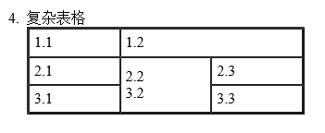

**4.使用JavaScript循环html代码**

**<html>**

**<head>**

**<title>文档标题</title>**

**</head>**

**<body>**

**<table border="1">**

**<tr class="text_center">**

**<script>**

**for (var i = 0; i < 6; i++) {**

**str = "<td width=\"60\" height=\"40\"></td>";**

**document.write(str);**

**}**

**</script>**

**</tr>**

**</table>**

**</body>**

**</html>**

**5. form标签**

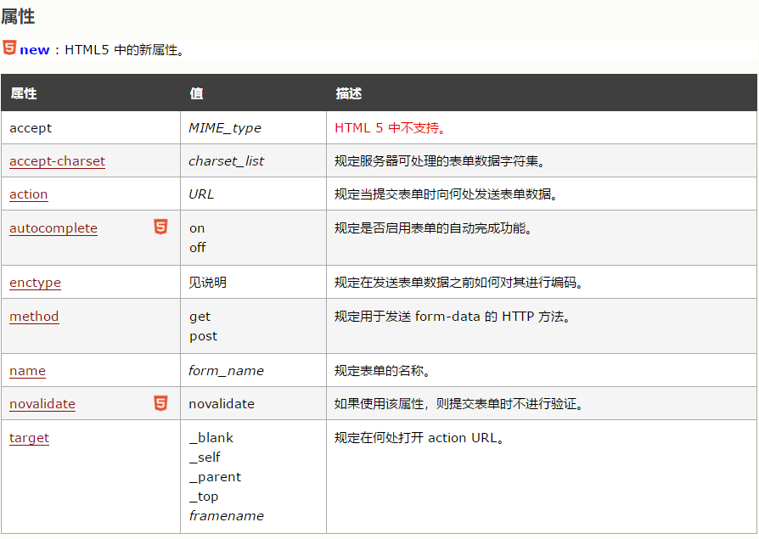

**6. 特殊符号**

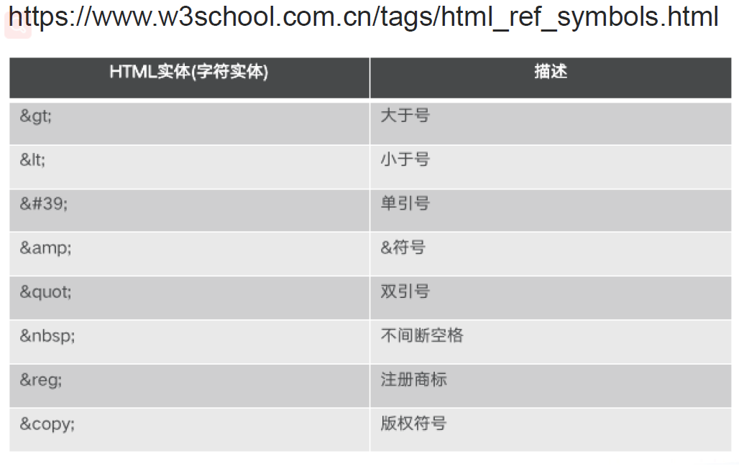

**7.按钮**

**提交按钮： <input type="submit" value="提交">**

**重置按钮： <input type="reset" value="重置">**

**选择文件按钮： <input type="file" name="uploadfile" value="Browse..."/>**

**点击图片跳链接按钮：<input type="image" width="60" src="./login.jpg" title="我是图片按钮哦"> <br>**

**8.函数调用**

**<html>**

**<script>**

**function loop()**

**{**

**with(document){**

**for(var i=0; i < 6; i ++){**

**write(i);**

**}**

**}**

**}**

**</script>**

**<body onload="loop()">**

**</html>**